Enhanced Theory of Change (EToC): School Governors Scheme

Table of contents
Enhanced Theory of Change diagram 2
Enhanced Theory of Change narrative 3
1. Background 3
Problem statement 3
2. Design and implementation 3
Inputs 3
Activities 4
Target group 5
Delivery stakeholders 5
Mode of delivery 5
Location 6
Timeframes 6
Tailoring 6
3. Expected change 6
Outcomes 6
Impact 7
4. Causal pathways and change mechanisms 7
Causal pathway 1 7
Change mechanisms 7
Causal pathway 2 8
Change mechanisms 8
5. Moderating factors 9
Moderating factors 9
6. Impact and outcome measures 10
Impact measures 10
Outcome measures 10
7. References 11

Enhanced Theory of Change diagram
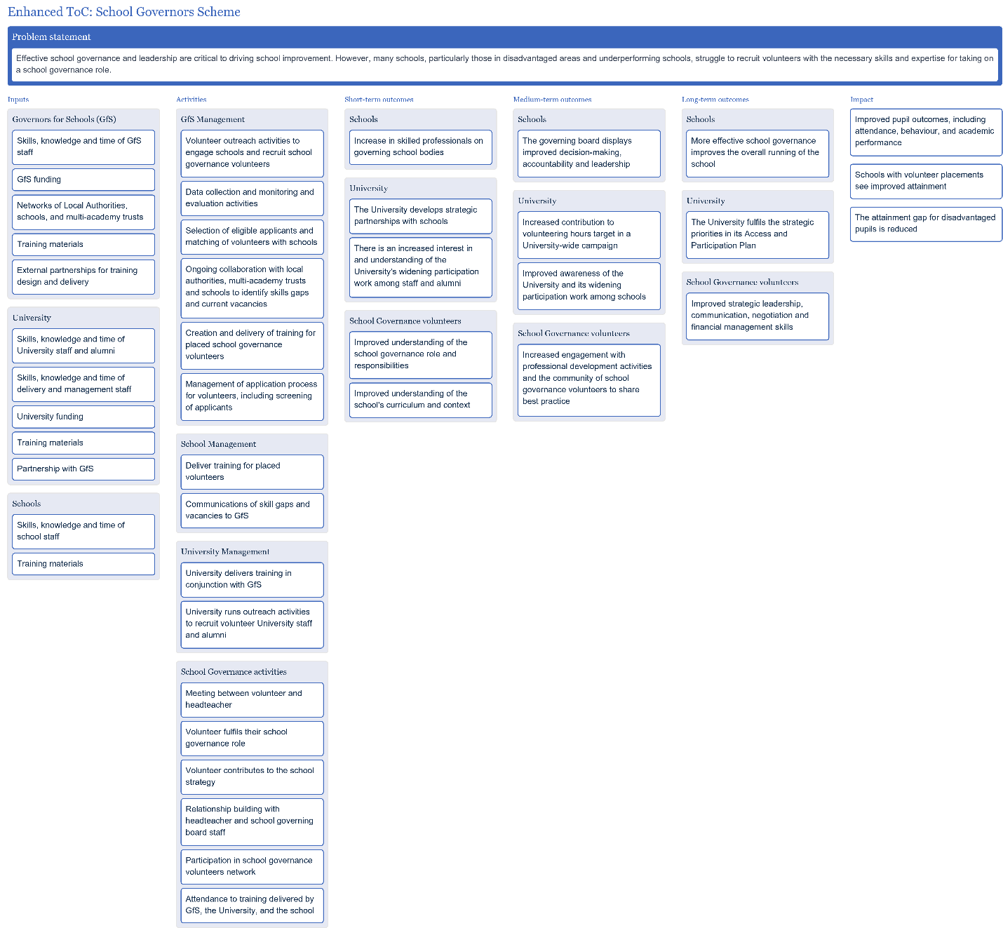

Enhanced Theory of Change narrative

Background

Problem statement
Effective school governance and leadership are critical to driving school improvement. However, many schools, particularly those in disadvantaged areas and underperforming schools, struggle to recruit volunteers with the necessary skills and expertise for taking on a school governance role.
Additional context
In a study, Higher Education Funding Council for England (HEFCE) examined HEPs sponsorship of academy schools and conducted an empirical analysis of the trends in pupils’ attainment and HE progression. The analysis found that there was a significant increase in pupil attainment at Key Stage 4 across all sponsored academies studied (Universities UK, 2017). However, schools have seen an increase in demand for school governors with specialised skill sets, and many are struggling to fill their vacancies with appropriate volunteers (Governors for Schools, 2025). Schools in disadvantaged areas are more heavily impacted by these challenges. This intervention aims to recruit and place university staff and alumni into school governance roles in England and Wales in partnership with Governors for Schools (GfS). This approach seeks to strategically match skilled individuals with vacancies in order to improve educational outcomes for pupils. The University project targets skills gaps mainly in disadvantaged areas to support underperforming schools, and contribute to improved school outcomes, including pupil attainment.

Design and implementation

Inputs
- Governors for Schools (GfS)
  - Skills, knowledge and time of GfS staff
  - GfS funding
  - Networks of Local Authorities, schools, and multi-academy trusts
  - Training materials (existing online and physical materials from GfS resources)
  - External partnerships for training design and delivery
- University
  - Skills, knowledge and time of University staff and alumni
  - Skills, knowledge and time of delivery and management staff
  - University funding (budgeted into the Schools and Outreach department)
  - Training materials
  - Partnership with GfS (overseen by a member of the Schools and Outreach team)
- Schools
  - Skills, knowledge and time of school staff
  - Training materials

Activities
GfS Management
- Volunteer outreach activities to engage schools and recruit school governance volunteers
  - Including presentations, social media campaigns, and headhunting activities
- Data collection and monitoring and evaluation activities
  - This includes sharing anonymised information on the number of University volunteers placed in schools with the University, so that the University can monitor its staff and alumni engagement in school boards, which contributes to their volunteer hour commitments.
- Selection of eligible applicants and matching of volunteers with schools
- Ongoing collaboration with local authorities, multi-academy trusts and schools to identify skills gaps and current vacancies
- Creation and delivery of training for placed school governance volunteers
  - Using existing GfS materials
- Management of application process for volunteers, including screening of applicants
  - Reviewing applications, selecting those that meet the eligibility criteria, and matching them with schools, based on the schools’ needs and volunteers’ skills. Once the matching has been done, schools’ headteachers and school governance volunteers are expected to meet to confirm they are happy with the allocation, and the school governance volunteer is provided with the opportunity to attend and observe one governing board meeting before committing to the role.
School Management
- Deliver training for placed volunteers
- Communications of skill gaps and vacancies to GfS
- Via a form on GfS website - this means placement of volunteers can be tailored to schools' needs

University Management
- University delivers training in conjunction with GfS
- University runs outreach activities to recruit volunteer University staff and alumni
  - This includes both in-person and online information events, as well as communications. The University is then responsible for managing interest from staff and alumni until they are formally placed with an appropriate school. This includes capturing information on engagement with the alumni network, which will be used to assess the performance of the initiative.

School Governance activities
- Meeting between volunteer and headteacher
  - Including observation of one governing board meeting
- Volunteer fulfils their school governance role
  - Involves working with other board members to plan the school’s strategic direction, oversee the school’s financial performance, and hold the headteacher and school leadership to account. School governance roles also involve challenging existing processes to drive school improvement in different areas such as wellbeing, inclusion, health and safety. School governance volunteers are also expected to join and contribute to a school governance volunteers’ network to share best practice and experiences with other volunteers. Ideally, governors will be in place for 4 years.
- Volunteer contributes to the school strategy
  - Contributions may include wellbeing, inclusion, health and safety
- Relationship building with headteacher and school governing board staff
- Participation in school governance volunteers network
- Attendance to training delivered by GfS, the University, and the school

Target group
The School Governors Scheme supports schools across England and Wales, from maintained schools to Multi-Academy Trusts, and mainly targets schools in disadvantaged areas and underperforming schools, identified using DfE school data.

Delivery stakeholders
The intervention is managed and coordinated by members of staff from the university in collaboration with GfS. GfS leads on recruiting and training university staff and alumni to fulfil school governance volunteer roles.

Mode of delivery
The recruitment and engagement of schools and volunteers, as well as the application process, matching of volunteers with schools, and training of volunteers is conducted entirely online.
School governance volunteers are typically expected to attend the school board meetings in person, though a small number of roles are remote.

Location
The programme coordination, promotion and recruitment of the programme is delivered on campus and virtually via university networks. GfS training for volunteers is typically online/virtual. Staff and alumni recruited for school governance roles as well as the schools involved are based across England and Wales.

Timeframes
Once the programme starts, the recruitment of volunteers and matching of volunteers with schools is anticipated to take place throughout the academic year. University staff and alumni would be able to apply to school governance volunteer roles at any time.
Once volunteers have been placed, they are expected to fulfil their role for 4 years.

Tailoring
This intervention is generally not tailored to participants, although the governance volunteer role can vary depending on the school context. GfS volunteers should take responsibility for their engagement with the training materials available online, and they should collaboratively agree with school boards on their role and responsibilities.

Expected change

Outcomes
Schools
- Increase in skilled professionals on governing school bodies
- The governing board displays improved decision-making, accountability and leadership
- More effective school governance improves the overall running of the school
University
- The University develops strategic partnerships with schools
- There is an increased interest in and understanding of the University's widening participation work among staff and alumni
- Increased contribution to volunteering hours target in a University-wide campaign
- Improved awareness of the University and its widening participation work among schools
- The University fulfils the strategic priorities in its Access and Participation Plan
School Governance volunteers
- Improved understanding of the school governance role and responsibilities
- Improved understanding of the school's curriculum and context
- Increased engagement with professional development activities and the community of school governance volunteers to share best practice
- Improved strategic leadership, communication, negotiation and financial management skills

Impact
- Improved pupil outcomes, including attendance, behaviour, and academic performance
- Schools with volunteer placements see improved attainment
- The attainment gap for disadvantaged pupils is reduced

Causal pathways and change mechanisms

Causal pathway 1
Placing trained governors with relevant and valuable skills into schools will improve the quality of school governance, and therefore improve decision-making, accountability, and leadership in schools.
This pathway hypothesises that, by training and placing volunteers in school governance roles, they will improve their understanding of the school’s context, needs, and curriculum, and also develop a clearer understanding of their responsibilities within the school. In turn, school governors are expected to be equipped with the necessary skills to contribute to school governance effectively, including relevant and valuable inputs. Assuming there are not wider barriers affecting school governance, it is anticipated that this contribution will improve school governance, decision-making, accountability, and leadership in schools.
In a study consisting of surveys and focus groups conducted by GfS and partners in 2019, participating governance volunteers reported the development of transferrable skills such as leadership and negotiation but also reported a growth in agility, analysing performance data and KPIs, and financial skills. Findings from the GfS survey with schools and volunteers also found that school governance volunteers have had significant professional progression, such as becoming a committee member (incl. a committee chair or Vice Chair) or a link governor.
The survey conducted by GfS also found that school governance volunteers are highly effective in making positive impacts on the schools they are placed in. Findings show that governors can impact schools through a range of actions, including advising on financial and strategic matters, reviewing and amending policy, providing leadership, and having advanced IT skills.
While these findings show promising evidence supporting this causal pathway, it is largely based on self-reported data without a comparison group. As such, more robust evidence is needed to confirm that the GfS programme leads to improved school governance.

Change mechanisms
- The school will deliver clear and effective training which clearly situates the school's context within the wider sector. After the training, the volunteers are provided with a selection of physical resources so that they continue to have access to this information after the training is complete.
- GfS will deliver extensive training at the start of the placement which covers the role and responsibilities of a school governor. The monitoring of feedback from previous iterations of this training has shown that, following the training, volunteers are more confident that they understand the role and can perform it effectively.
- Improved understanding of the school's context and the responsibilities of a school governor, will increase the volunteers' confidence and competence. This will result in them making effective and valuable contributions to the school governance, which will support the board with effective decision-making.

Causal pathway 2
Improved governance, decision-making, accountability and leadership in schools will lead to improved school performance and outcomes for students.
The second pathway follows on from the first, largely looking at the hypothesis that improved governance, decision-making, accountability and leadership in schools will lead to improved school performance, pupil outcomes, and attainment. This is expected to take place as more effective school boards are expected to have better strategic planning and better financial resource management than school boards with skills gaps. In turn, this is anticipated to result in improved outcomes both financially (e.g., financial resources better allocated) and for pupils’ education (e.g. resources allocated to meet pupils’ needs and provide adequate support). By ensuring pupils receive the support and education they need – including adequate resources, material, facilities, and support services – they are expected to have better outcomes such as improved attendance and academic performance, leading to overall improved attainment.
There is some evidence to support the link between improved governance in schools and improved pupil outcomes, and it is a key area reviewed by Ofsted. The Education Endowment Foundation (EEF) states that school governors and trustees play a crucial role in improving school performance by providing support and challenge to the headteacher and their leadership team, and they produced a report on becoming an evidence-informed governor.
However, according to TASO’s Rapid Evidence Review, the strength of evidence for school governance interventions – which include university members becoming governors of schools – is weak, as existing research does not demonstrate a causal link between these interventions and attainment. Therefore, as noted above, more robust evidence is needed to assess whether the GfS programme leads to improved school governance and if in turn, this leads to improved pupil outcomes including attainment. Attributing the impact to the programme may be challenging due to the many other factors affecting pupil performance.

Change mechanisms
- There is some limited evidence (Golding, 2019; Universities UK, 2017) which suggests that sponsorship of a local school could be associated with an increase in pupil attainment and HE progression. The assumption is that interventions focus on enhancing institutional-level factors contribute to improved attainment for individual students.
- Improved decision-making in school boards is expected to result in better strategic planning and better financial resource management than school boards with skills gaps, which makes the overall running of the school more effective.

Moderating factors

Moderating factors
- Effective collaboration between schools and GfS so that needs and vacancies are communicated
- Volunteers and schools are willing and able to provide feedback as part of monitoring and evaluation
  - Mitigation: Make evaluation processes straightforward and embed them in existing activities as much as possible. Make use of data that is routinely collected for monitoring.
- Volunteers are not put off by uncertainty around onboarding times and remote locations of schools in some disadvantaged areas
- Adequate and sustained resourcing from the University and GfS to run the programme
  - Mitigation: Commitment to funding in University strategy
- Volunteer governor training is effective and accessible
  - Improves skills relevant for the governor role (e.g., strategic leadership, financial management, negotiation skills).
  - Mitigation: Draw on GfS's previous expertise in this field, and allow opportunity for tailoring of training to volunteer needs.
- Appropriate targeting of communication and recruitment activities to ensure they meet the intended audience
  - Mitigation: Drawing on GfS's prior experience of recruiting volunteers, making use of University staff and alumni networks
- Lack of resources in schools
  - Lack of resources (e.g., staff or budget) could complicate the improvement of the schools’ governance, impact the retention and development of skilled governance volunteers, and hinder positive changes in the schools’ curriculum and direction that can affect the achievement of improved pupil outcomes.
- Commitment and availability of school governance volunteers
  - Mitigation: Make the opportunity look as attractive as possible by highlighting benefits to all stakeholders involved.
- Difficult school contexts can challenge the fulfilment of anticipated impacts
  - Pupil outcomes are impacted by wider factors outside of the control of the intervention or the changes governors are able to make.
- Volunteers contribute to a governance network
  - Mitigation: Make access to the network easy, low commitment, and mutually beneficial for governors
- School governance volunteers fill the skills gaps in the school board
  - Mitigation: Effective identification of skills gaps in schools and of skills brought by volunteers, plus high-quality matching between schools and volunteers.

Impact and outcome measures

Impact measures
Impact | Impact measure
Improved pupil outcomes, including attendance, behaviour, and academic performance | Data provided by schools
Schools with volunteer placements see improved attainment | Tracking attainment via HEAT Track; potential for developing a counterfactual group in the future
The attainment gap for disadvantaged pupils is reduced | Tracking attainment via HEAT Track; potential for developing a counterfactual group in the future

Outcome measures
Outcome | Outcome measure
Increase in skilled professionals on governing school bodies | Survey issued to schools
The governing board displays improved decision-making, accountability and leadership | Survey issued to schools
Increased contribution to volunteering hours target in a University-wide campaign | Data collected by the University
The University fulfils the strategic priorities in its Access and Participation Plan | APP monitoring
Improved understanding of the school governance role and responsibilities | Survey issued to governance volunteers at multiple stages throughout the intervention
Improved understanding of the school's curriculum and context | Survey issued to governance volunteers at multiple stages throughout the intervention
Increased engagement with professional development activities and the community of school governance volunteers to share best practice | Survey issued to governance volunteers at multiple stages throughout the intervention
Improved strategic leadership, communication, negotiation and financial management skills | Survey issued to governance volunteers at multiple stages throughout the intervention

References
- Golding, J., (2019). “Progression through a mathematics specialist school: a study of trajectories of the first two cohorts through King’s College London Mathematics School.” UCL Institute of Education.
- Universities UK (2016). “Working in Partnership: Enabling Social Mobility in Higher Education. The final report of the Social Mobility Advisory Group.”
- TASO (2022). Typology of attainment-raising activities conducted by HEPs: Rapid Evidence Review. https://cdn.taso.org.uk/wp-content/uploads/TASO-attainment-raising-typology-and-rapid-evidence-review-1.pdf
- Education Endowment Foundation (2019). The EEF guide to becoming an evidence-informed school governor and trustee. https://educationendowmentfoundation.org.uk/education-evidence/bitesize-support/guide-for-governing-boards#:~:text=Education%20Endowment%20Foundation%3AGuide%20for%20governing%20boards&text=School%20governors%20and%20trustees%20play,headteacher%20and%20their%20leadership%20team.

